Syed Sualeh Abbas

Syed Zaid Naqvi

Syed Mohsin

Lab 5: Designing FSM Using FPGA Switches and LEDs

Task 1:

FSM Design and State Diagram

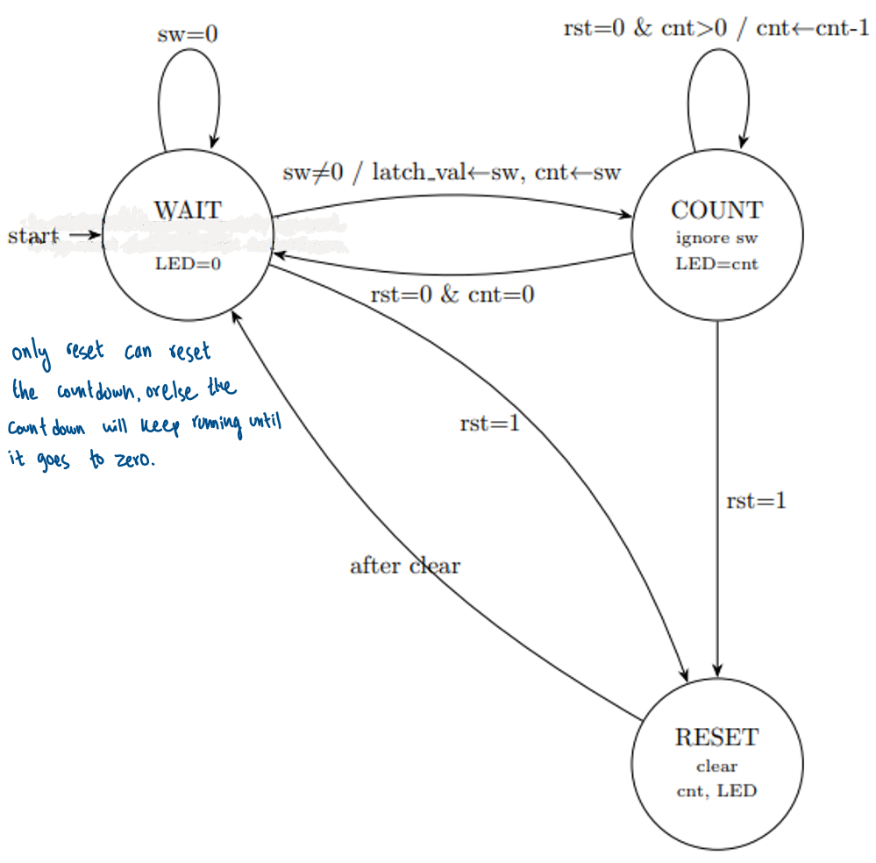

Task 2: Verilog FSM and Counter Implementation

Verilog source file for FSM and counter

`timescale 1ns / 1ps

module debouncher(

input wire clk,

input wire pbin,

output reg pbout

);

// Debounce using a counter: output changes only when input stays stable long enough

// With 100 MHz, COUNT_MAX=2_000_000 ~ 20ms

parameter integer COUNT_MAX = 2_000_000;

reg sync1 = 0, sync2 = 0;

reg [31:0] cnt = 0;

reg stable = 0;

always @(posedge clk) begin

// 2-flop synchronizer

sync1 <= pbin;

sync2 <= sync1;

if (sync2 == stable) begin

cnt <= 0; // already stable

end else begin

if (cnt == COUNT_MAX-1) begin

stable <= sync2;

cnt <= 0;

end else begin

cnt <= cnt + 1;

end

end

pbout <= stable;

end

endmodule

`timescale 1ns / 1ps

module switches(

input wire clk, rst,

input wire [15:0] btns, // not used here

input wire [31:0] writeData, // not used

input wire writeEnable, // not used

input wire readEnable,

input wire [29:0] memAddress,

input wire [15:0] switches,

output reg [31:0] readData

);

reg [7:0] switchData [3:0];

// Address for switches peripheral

localparam [29:0] SW_ADDR = 30'h00000001;

always @(posedge clk) begin

if (rst) begin

readData <= 32'd0;

switchData[0] <= 8'd0;

switchData[1] <= 8'd0;

switchData[2] <= 8'd0;

switchData[3] <= 8'd0;

end else begin

// store switch bytes (optional, matches your skeleton)

switchData[0] <= switches[7:0];

switchData[1] <= switches[15:8];

switchData[2] <= 8'd0;

switchData[3] <= 8'd0;

// read transaction

if (readEnable && memAddress == SW_ADDR)

readData <= {16'd0, switches};

else

readData <= 32'd0;

end

end

endmodule

`timescale 1ns / 1ps

module leds(

input wire clk,

input wire rst,

input wire [31:0] writeData,

input wire writeEnable,

input wire readEnable, // not used

input wire [29:0] memAddress,

output reg [31:0] readData = 0, // not to be read

output reg [15:0] leds

);

reg [7:0] ledData [3:0];

// Address for LED peripheral

localparam [29:0] LED_ADDR = 30'h00000002;

integer i;

always @(posedge clk) begin

if (rst) begin

leds <= 16'd0;

for (i = 0; i < 4; i = i + 1)

ledData[i] <= 8'd0;

end else begin

if (writeEnable && memAddress == LED_ADDR) begin

ledData[0] <= writeData[7:0];

ledData[1] <= writeData[15:8];

ledData[2] <= writeData[23:16];

ledData[3] <= writeData[31:24];

leds <= writeData[15:0];

end

end

end

endmodule

`timescale 1ns / 1ps

module Task01_using_peripherals #(

parameter integer DIV_MAX = 100_000_000

)(

input wire clk,

input wire btnC, // RESET raw

input wire [15:0] sw, // physical switches

output wire [6:0] seg,

output wire [3:0] an,

output wire [15:0] led // driven by leds module

);

// -----------------------------

// Debounced reset

// -----------------------------

wire rst;

debouncher u_db (

.clk(clk),

.pbin(btnC),

.pbout(rst)

);

// -----------------------------

// MMIO addressing

// -----------------------------

localparam [29:0] SW_ADDR = 30'h00000001;

localparam [29:0] LED_ADDR = 30'h00000002;

// Switch peripheral signals

reg sw_readEnable;

wire [31:0] sw_readData;

// LED peripheral signals

reg [31:0] led_writeData;

reg led_writeEnable;

// Instantiate peripherals

switches u_switches (

.clk(clk),

.rst(rst),

.btns(16'd0),

.writeData(32'd0),

.writeEnable(1'b0),

.readEnable(sw_readEnable),

.memAddress(SW_ADDR),

.switches(sw),

.readData(sw_readData)

);

leds u_leds (

.clk(clk),

.rst(rst),

.writeData(led_writeData),

.writeEnable(led_writeEnable),

.readEnable(1'b0),

.memAddress(LED_ADDR),

.readData(),

.leds(led)

);

// -----------------------------

// 1 Hz tick generator

// -----------------------------

reg [31:0] div;

wire tick_1hz = (div == (DIV_MAX-1));

always @(posedge clk) begin

if (rst)

div <= 0;

else if (tick_1hz)

div <= 0;

else

div <= div + 1;

end

// -----------------------------

// Priority encoder

// -----------------------------

function [3:0] encode;

input [15:0] s;

begin

casex (s)

16'b1xxx_xxxx_xxxx_xxxx: encode = 4'd15;

16'b01xx_xxxx_xxxx_xxxx: encode = 4'd14;

16'b001x_xxxx_xxxx_xxxx: encode = 4'd13;

16'b0001_xxxx_xxxx_xxxx: encode = 4'd12;

16'b0000_1xxx_xxxx_xxxx: encode = 4'd11;

16'b0000_01xx_xxxx_xxxx: encode = 4'd10;

16'b0000_001x_xxxx_xxxx: encode = 4'd9;

16'b0000_0001_xxxx_xxxx: encode = 4'd8;

16'b0000_0000_1xxx_xxxx: encode = 4'd7;

16'b0000_0000_01xx_xxxx: encode = 4'd6;

16'b0000_0000_001x_xxxx: encode = 4'd5;

16'b0000_0000_0001_xxxx: encode = 4'd4;

16'b0000_0000_0000_1xxx: encode = 4'd3;

16'b0000_0000_0000_01xx: encode = 4'd2;

16'b0000_0000_0000_001x: encode = 4'd1;

default: encode = 4'd0;

endcase

end

endfunction

// Read switches continuously (MMIO read)

reg [15:0] sw_sample;

reg [15:0] sw_prev;

wire [3:0] preview_value = encode(sw_sample);

wire any_sw_rise = |(sw_sample & ~sw_prev);

always @(posedge clk) begin

if (rst) begin

sw_readEnable <= 1'b0;

sw_sample <= 16'd0;

sw_prev <= 16'd0;

end else begin

sw_readEnable <= 1'b1;

sw_prev <= sw_sample;

sw_sample <= sw_readData[15:0];

end

end

// -----------------------------

// FSM (same behavior as your Task01)

// -----------------------------

localparam IDLE = 2'b00;

localparam COUNT = 2'b01;

localparam DONE = 2'b10;

reg [1:0] state;

reg [3:0] counter;

always @(posedge clk) begin

if (rst) begin

state <= IDLE;

counter <= 4'd0;

end else begin

case (state)

IDLE: begin

counter <= preview_value; // preview

if (any_sw_rise && (preview_value != 4'd0)) begin

counter <= preview_value; // latch once

state <= COUNT;

end

end

COUNT: begin

if (tick_1hz) begin

if (counter > 0)

counter <= counter - 1;

else

state <= DONE;

end

end

DONE: begin

counter <= 4'd0;

if (any_sw_rise && (preview_value != 4'd0)) begin

counter <= preview_value;

state <= COUNT;

end

end

endcase

end

end

// -----------------------------

// Drive LED peripheral (MMIO write)

// same mapping as before:

// led[3:0]=counter, led[5:4]=state, led[9:6]=preview

// -----------------------------

always @(posedge clk) begin

if (rst) begin

led_writeEnable <= 1'b0;

led_writeData <= 32'd0;

end else begin

led_writeEnable <= 1'b1;

led_writeData <= {22'd0, preview_value, state, counter};

end

end

// -----------------------------

// 7-seg HEX (0..F) rightmost digit

// -----------------------------

assign an = 4'b1110;

function [6:0] hex7seg;

input [3:0] x;

begin

case (x)

4'h0: hex7seg = 7'b1000000;

4'h1: hex7seg = 7'b1111001;

4'h2: hex7seg = 7'b0100100;

4'h3: hex7seg = 7'b0110000;

4'h4: hex7seg = 7'b0011001;

4'h5: hex7seg = 7'b0010010;

4'h6: hex7seg = 7'b0000010;

4'h7: hex7seg = 7'b1111000;

4'h8: hex7seg = 7'b0000000;

4'h9: hex7seg = 7'b0010000;

4'hA: hex7seg = 7'b0001000;

4'hB: hex7seg = 7'b0000011;

4'hC: hex7seg = 7'b1000110;

4'hD: hex7seg = 7'b0100001;

4'hE: hex7seg = 7'b0000110;

4'hF: hex7seg = 7'b0001110;

endcase

end

endfunction

assign seg = hex7seg(counter);

endmodule

Testbench file for FSM and counter

`timescale 1ns / 1ps

module Task01_using_peripherals_tb;

// -------------------------

// Parameters - match the REAL hardware values exactly

// No parameter overrides needed; design runs as on board

// -------------------------

localparam integer CLK_PERIOD = 10; // 10ns = 100 MHz

localparam integer DB_CYCLES = 2_000_000; // debouncer COUNT_MAX

localparam integer TICK_CYCLES = 100_000_000; // 1Hz tick DIV_MAX

// -------------------------

// DUT signals

// -------------------------

reg clk;

reg btnC;

reg [15:0] sw;

wire [6:0] seg;

wire [3:0] an;

wire [15:0] led;

// -------------------------

// Instantiate DUT - no overrides, pure hardware config

// -------------------------

Task01_using_peripherals dut (

.clk (clk),

.btnC(btnC),

.sw (sw),

.seg (seg),

.an (an),

.led (led)

);

// -------------------------

// Clock generation

// -------------------------

initial clk = 0;

always #(CLK_PERIOD/2) clk = ~clk;

// -------------------------

// Helper task: apply reset

// Holds btnC HIGH for DB_CYCLES+100 clocks so debouncer completes

// -------------------------

task do_reset;

begin

$display("[RESET] Asserting btnC HIGH for %0d cycles...", DB_CYCLES+100);

btnC = 1;

#(CLK_PERIOD * (DB_CYCLES + 100)); // outlast the debouncer

btnC = 0;

#(CLK_PERIOD * 100); // settle

$display("[RESET] Done. rst should have fired.");

end

endtask

// -------------------------

// Helper task: press a switch value, hold briefly, then release

// -------------------------

task press_sw;

input [15:0] sw_val;

input integer hold_cycles;

begin

sw = sw_val;

#(CLK_PERIOD * hold_cycles);

sw = 16'd0;

end

endtask

// -------------------------

// Helper: wait for N complete 1Hz ticks

// One tick = TICK_CYCLES clocks = 1 real second

// -------------------------

task wait_ticks;

input integer n;

begin

#(CLK_PERIOD * TICK_CYCLES * n);

end

endtask

// -------------------------

// Test sequence

// -------------------------

initial begin

// Initialise

btnC = 0;

sw = 16'd0;

#(CLK_PERIOD * 10);

// ======================================================

// RESET - hold btnC long enough for the real debouncer

// ======================================================

$display("\n========================================");

$display("[RESET] Starting reset sequence");

$display("========================================");

do_reset;

$display("[RESET] Expecting: state=IDLE, counter=0, seg=1000000 (digit 0)");

#(CLK_PERIOD * 50);

// ======================================================

// TEST 1: sw[2] only -> priority encode = 2

// FSM: IDLE -> COUNT(2) -> COUNT(1) -> COUNT(0) -> DONE

// ======================================================

$display("\n========================================");

$display("[Test 1] sw[2] HIGH => priority = 2");

$display(" Expect: latch 2, count 2->1->0, then DONE");

$display("========================================");

press_sw(16'b0000_0000_0000_0100, 10);

wait_ticks(4); // 2 ticks to count down + 2 margin

$display("[Test 1] Done. Expecting state=DONE, counter=0");

#(CLK_PERIOD * 50);

// ======================================================

// TEST 2: sw[15] only -> priority encode = 15

// ======================================================

$display("\n========================================");

$display("[Test 2] sw[15] HIGH => priority = 15");

$display(" Expect: latch 15, count 15->0, then DONE");

$display("========================================");

press_sw(16'b1000_0000_0000_0000, 10);

wait_ticks(17); // 15 ticks + 2 margin

$display("[Test 2] Done. Expecting state=DONE, counter=0");

#(CLK_PERIOD * 50);

// ======================================================

// TEST 3: sw[14] and sw[2] both HIGH -> priority = 14

// ======================================================

$display("\n========================================");

$display("[Test 3] sw[14]+sw[2] => priority = 14 (highest wins)");

$display(" Expect: latch 14, count 14->0, then DONE");

$display("========================================");

press_sw(16'b0100_0000_0000_0100, 10);

wait_ticks(16); // 14 ticks + 2 margin

$display("[Test 3] Done. Expecting state=DONE, counter=0");

#(CLK_PERIOD * 50);

// ======================================================

// TEST 4: Re-trigger from DONE

// ======================================================

$display("\n========================================");

$display("[Test 4] Re-trigger from DONE state");

$display(" Step A: sw[1] => priority 1, wait for DONE");

$display("========================================");

press_sw(16'b0000_0000_0000_0010, 10); // sw[1] = priority 1

wait_ticks(3);

$display("[Test 4] In DONE. Now pressing sw[3] to re-trigger...");

press_sw(16'b0000_0000_0000_1000, 10); // sw[3] = priority 3

wait_ticks(5);

$display("[Test 4] Done. Expecting state=DONE, counter=0");

#(CLK_PERIOD * 50);

// ======================================================

// TEST 5: No switch -> stays IDLE

// ======================================================

$display("\n========================================");

$display("[Test 5] No switch pressed -> stays IDLE");

$display("========================================");

wait_ticks(3);

$display("[Test 5] Done. Expecting state=IDLE, counter=0");

// ======================================================

// TEST 6: Reset mid-count

// ======================================================

$display("\n========================================");

$display("[Test 6] Reset during COUNT");

$display(" sw[8] => priority 8, reset after 3 ticks");

$display("========================================");

press_sw(16'b0000_0001_0000_0000, 10); // sw[8] = priority 8

wait_ticks(3);

$display("[Test 6] Applying reset now (counter should be ~5)...");

do_reset;

$display("[Test 6] Done. Expecting state=IDLE, counter=0");

#(CLK_PERIOD * 50);

$display("\n========================================");

$display("===== All Tests Complete =====");

$display("========================================");

$finish;

end

// -------------------------

// Decode LED fields

// led[3:0] = counter

// led[5:4] = state (00=IDLE, 01=COUNT, 10=DONE)

// led[9:6] = preview_value

// -------------------------

reg [1:0] state_bits;

reg [3:0] counter_bits;

reg [3:0] preview_bits;

reg [8*5-1:0] state_name;

always @(*) begin

counter_bits = led[3:0];

state_bits = led[5:4];

preview_bits = led[9:6];

case (state_bits)

2'b00: state_name = "IDLE ";

2'b01: state_name = "COUNT";

2'b10: state_name = "DONE ";

default: state_name = "?????";

endcase

end

// -------------------------

// Print only on changes to avoid billions of identical lines

// -------------------------

reg [1:0] last_state;

reg [3:0] last_counter;

reg [3:0] last_preview;

reg last_btnC;

reg [15:0] last_sw;

initial begin

last_state = 2'bxx;

last_counter = 4'bxxxx;

last_preview = 4'bxxxx;

last_btnC = 1'bx;

last_sw = 16'bx;

$display("\n%-14s | %-5s | %-5s | %-16s | %-5s | ctr | prev | seg",

"Time(ns)", "btnC", "rst", "sw", "state");

end

always @(posedge clk) begin

#1;

if (state_bits !== last_state ||

counter_bits !== last_counter ||

preview_bits !== last_preview ||

btnC !== last_btnC ||

sw !== last_sw)

begin

$display("%-14t | %-5b | %-5b | %b | %s | %2d | %2d | %7b",

$time,

btnC,

dut.rst,

sw,

state_name,

counter_bits,

preview_bits,

seg);

last_state <= state_bits;

last_counter <= counter_bits;

last_preview <= preview_bits;

last_btnC <= btnC;

last_sw <= sw;

end

end

endmodule

Simulation waveforms showing correct operation

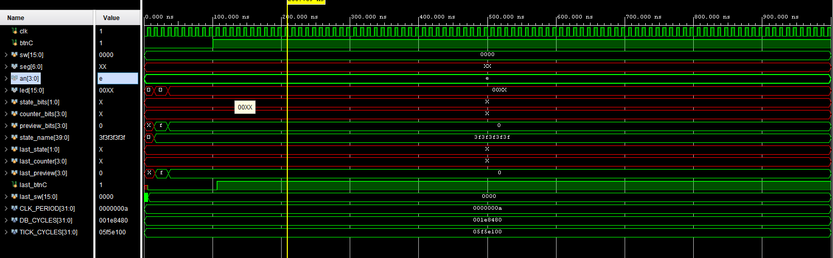

Task 3: FPGA Constraints, XDC File and Timing Analysis

XDC file

set_property PACKAGE_PIN E3 [get_ports clk]

set_property IOSTANDARD LVCMOS33 [get_ports clk]

create_clock -period 10.000 -name sys_clk [get_ports clk]

## Reset (btnC center button)

set_property PACKAGE_PIN N17 [get_ports btnC]

set_property IOSTANDARD LVCMOS33 [get_ports btnC]

## Switches

set_property PACKAGE_PIN J15 [get_ports {sw[0]}]

set_property IOSTANDARD LVCMOS33 [get_ports {sw[0]}]

set_property PACKAGE_PIN L16 [get_ports {sw[1]}]

set_property IOSTANDARD LVCMOS33 [get_ports {sw[1]}]

set_property PACKAGE_PIN M13 [get_ports {sw[2]}]

set_property IOSTANDARD LVCMOS33 [get_ports {sw[2]}]

set_property PACKAGE_PIN R15 [get_ports {sw[3]}]

set_property IOSTANDARD LVCMOS33 [get_ports {sw[3]}]

set_property PACKAGE_PIN R17 [get_ports {sw[4]}]

set_property IOSTANDARD LVCMOS33 [get_ports {sw[4]}]

set_property PACKAGE_PIN T18 [get_ports {sw[5]}]

set_property IOSTANDARD LVCMOS33 [get_ports {sw[5]}]

set_property PACKAGE_PIN U18 [get_ports {sw[6]}]

set_property IOSTANDARD LVCMOS33 [get_ports {sw[6]}]

set_property PACKAGE_PIN R13 [get_ports {sw[7]}]

set_property IOSTANDARD LVCMOS33 [get_ports {sw[7]}]

set_property PACKAGE_PIN T8 [get_ports {sw[8]}]

set_property IOSTANDARD LVCMOS33 [get_ports {sw[8]}]

set_property PACKAGE_PIN U8 [get_ports {sw[9]}]

set_property IOSTANDARD LVCMOS33 [get_ports {sw[9]}]

set_property PACKAGE_PIN R16 [get_ports {sw[10]}]

set_property IOSTANDARD LVCMOS33 [get_ports {sw[10]}]

set_property PACKAGE_PIN T13 [get_ports {sw[11]}]

set_property IOSTANDARD LVCMOS33 [get_ports {sw[11]}]

set_property PACKAGE_PIN H6 [get_ports {sw[12]}]

set_property IOSTANDARD LVCMOS33 [get_ports {sw[12]}]

set_property PACKAGE_PIN U12 [get_ports {sw[13]}]

set_property IOSTANDARD LVCMOS33 [get_ports {sw[13]}]

set_property PACKAGE_PIN U11 [get_ports {sw[14]}]

set_property IOSTANDARD LVCMOS33 [get_ports {sw[14]}]

set_property PACKAGE_PIN V10 [get_ports {sw[15]}]

set_property IOSTANDARD LVCMOS33 [get_ports {sw[15]}]

## LEDs

set_property PACKAGE_PIN H17 [get_ports {led[0]}]

set_property IOSTANDARD LVCMOS33 [get_ports {led[0]}]

set_property PACKAGE_PIN K15 [get_ports {led[1]}]

set_property IOSTANDARD LVCMOS33 [get_ports {led[1]}]

set_property PACKAGE_PIN J13 [get_ports {led[2]}]

set_property IOSTANDARD LVCMOS33 [get_ports {led[2]}]

set_property PACKAGE_PIN N14 [get_ports {led[3]}]

set_property IOSTANDARD LVCMOS33 [get_ports {led[3]}]

set_property PACKAGE_PIN R18 [get_ports {led[4]}]

set_property IOSTANDARD LVCMOS33 [get_ports {led[4]}]

set_property PACKAGE_PIN V17 [get_ports {led[5]}]

set_property IOSTANDARD LVCMOS33 [get_ports {led[5]}]

set_property PACKAGE_PIN U17 [get_ports {led[6]}]

set_property IOSTANDARD LVCMOS33 [get_ports {led[6]}]

set_property PACKAGE_PIN U16 [get_ports {led[7]}]

set_property IOSTANDARD LVCMOS33 [get_ports {led[7]}]

set_property PACKAGE_PIN V16 [get_ports {led[8]}]

set_property IOSTANDARD LVCMOS33 [get_ports {led[8]}]

set_property PACKAGE_PIN T15 [get_ports {led[9]}]

set_property IOSTANDARD LVCMOS33 [get_ports {led[9]}]

set_property PACKAGE_PIN U14 [get_ports {led[10]}]

set_property IOSTANDARD LVCMOS33 [get_ports {led[10]}]

set_property PACKAGE_PIN T16 [get_ports {led[11]}]

set_property IOSTANDARD LVCMOS33 [get_ports {led[11]}]

set_property PACKAGE_PIN V15 [get_ports {led[12]}]

set_property IOSTANDARD LVCMOS33 [get_ports {led[12]}]

set_property PACKAGE_PIN V14 [get_ports {led[13]}]

set_property IOSTANDARD LVCMOS33 [get_ports {led[13]}]

set_property PACKAGE_PIN V12 [get_ports {led[14]}]

set_property IOSTANDARD LVCMOS33 [get_ports {led[14]}]

set_property PACKAGE_PIN V11 [get_ports {led[15]}]

set_property IOSTANDARD LVCMOS33 [get_ports {led[15]}]

## 7-segment display

set_property PACKAGE_PIN T10 [get_ports {seg[0]}]

set_property IOSTANDARD LVCMOS33 [get_ports {seg[0]}]

set_property PACKAGE_PIN R10 [get_ports {seg[1]}]

set_property IOSTANDARD LVCMOS33 [get_ports {seg[1]}]

set_property PACKAGE_PIN K16 [get_ports {seg[2]}]

set_property IOSTANDARD LVCMOS33 [get_ports {seg[2]}]

set_property PACKAGE_PIN K13 [get_ports {seg[3]}]

set_property IOSTANDARD LVCMOS33 [get_ports {seg[3]}]

set_property PACKAGE_PIN P15 [get_ports {seg[4]}]

set_property IOSTANDARD LVCMOS33 [get_ports {seg[4]}]

set_property PACKAGE_PIN T11 [get_ports {seg[5]}]

set_property IOSTANDARD LVCMOS33 [get_ports {seg[5]}]

set_property PACKAGE_PIN L18 [get_ports {seg[6]}]

set_property IOSTANDARD LVCMOS33 [get_ports {seg[6]}]

## 7-segment anodes

set_property PACKAGE_PIN J17 [get_ports {an[0]}]

set_property IOSTANDARD LVCMOS33 [get_ports {an[0]}]

set_property PACKAGE_PIN J18 [get_ports {an[1]}]

set_property IOSTANDARD LVCMOS33 [get_ports {an[1]}]

set_property PACKAGE_PIN T9 [get_ports {an[2]}]

set_property IOSTANDARD LVCMOS33 [get_ports {an[2]}]

set_property PACKAGE_PIN J14 [get_ports {an[3]}]

set_property IOSTANDARD LVCMOS33 [get_ports {an[3]}]

Screenshot of Vivado Timing Summary

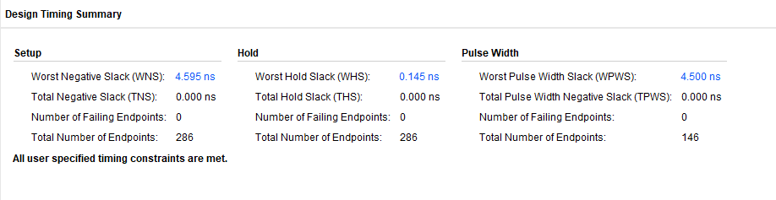

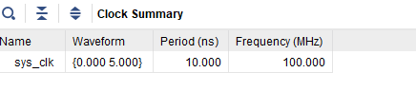

WNS value and interpretation (PASS / MARGINAL / FAIL)

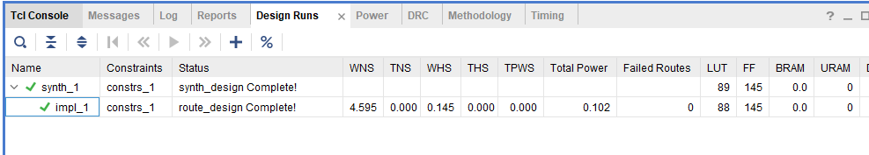

Task 4: FPGA Synthesis and On-Board Verification

RTL schematic screenshots

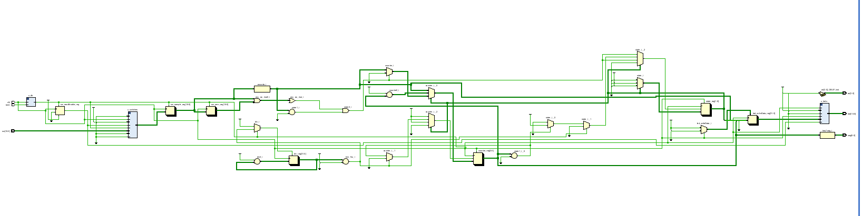

Successful FPGA demonstration

COUNTDOWN FROM 3 TO ZERO

(Because we turned on 3rd Switch)

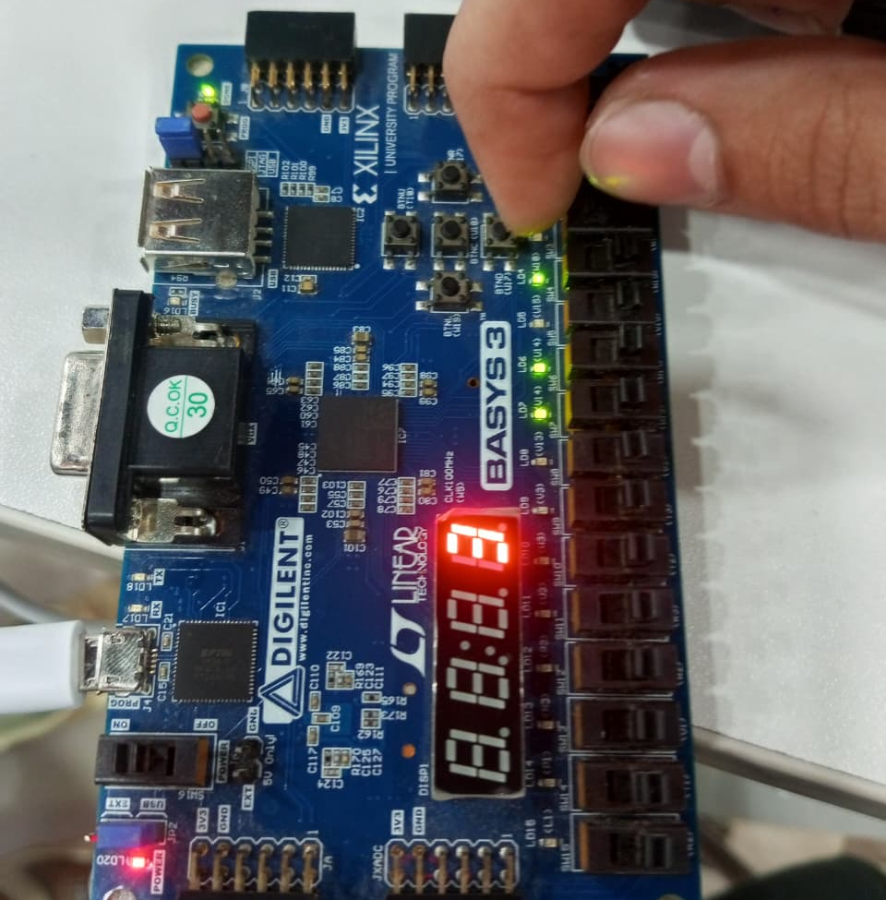

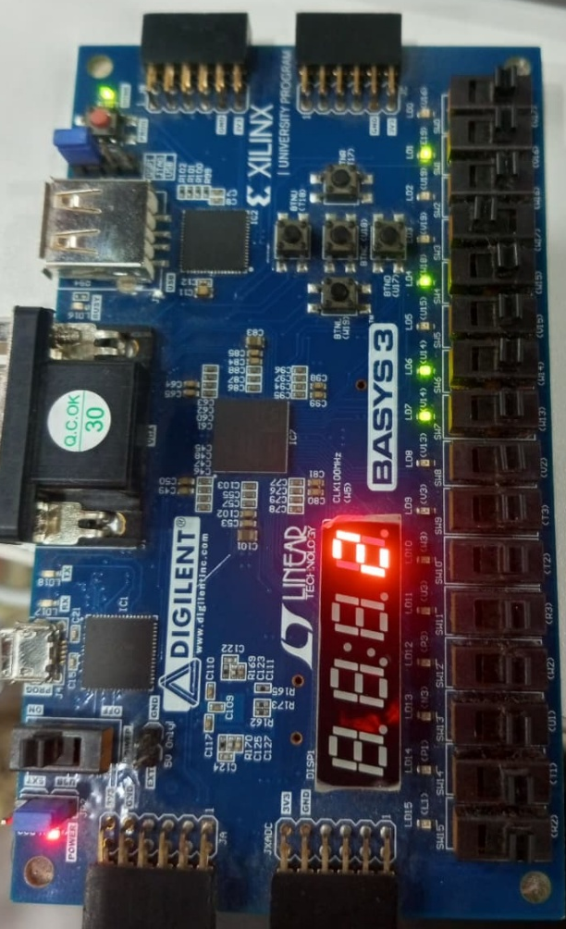

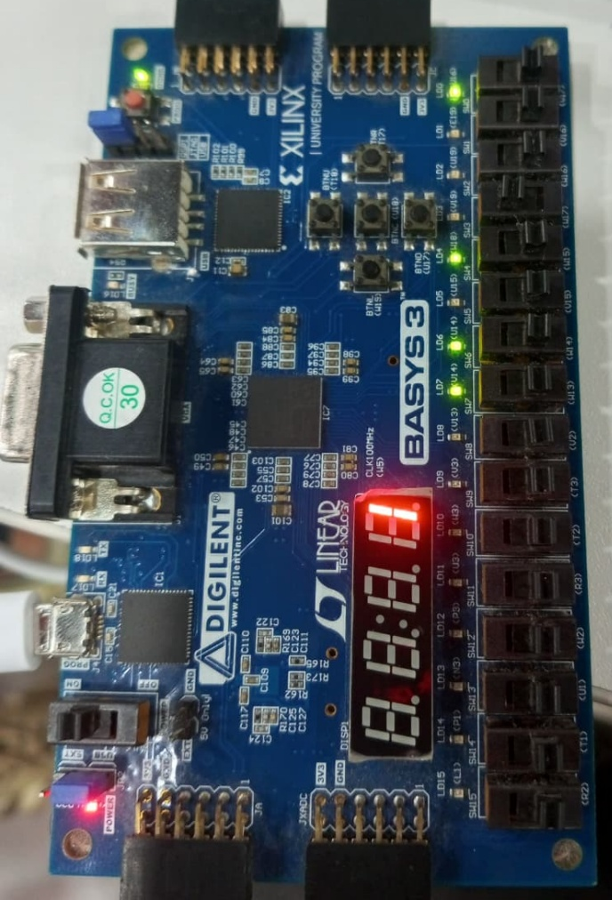

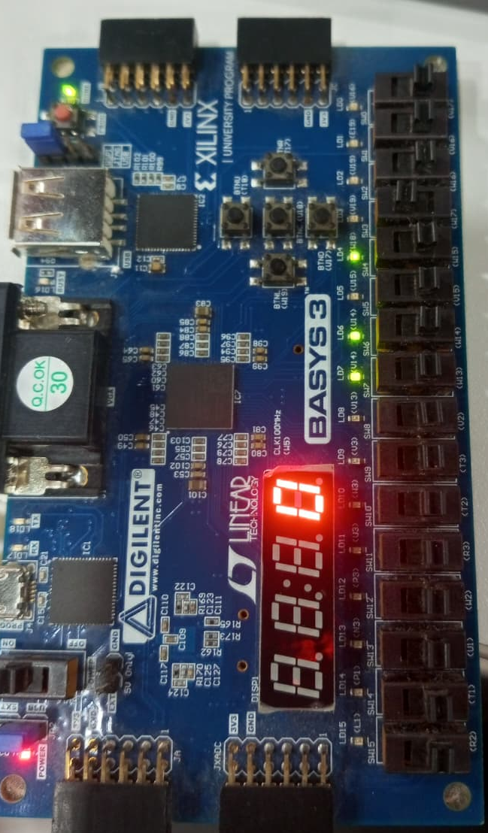

Assessment Rubric
Lab 5: Designing FSM Using FPGA Switches and LEDs

Name: | Student ID: | Section:

Points Distribution

 | Task No. | LR 2 (Code) | LR 5 (Results) | LR 11  (Design)
In-Lab | Pre lab | - | /15 | -
In-Lab | Task 1 | - | - | /10
In-Lab | Task 2 | /15 | /15 | -
In-Lab | Task 3 | - | /10 | -
In-Lab | Task 4 | - | /15
Total Points |  | /15 | /55 | /10
CLO Mapped |  | CLO 1

Affective Domain Rubric |  | Points | CLO Mapped
AR7 | Report Submission & Git Upload | /10 & /10 | CLO 1

CLO | Total Points | Points Obtained
1 | 100
Total | 100

For description of different levels of the mapped rubrics, please refer to the Lab Evaluation Assessment Rubrics and Affective Domain Assessment Rubrics provided here.

